Piter Garcia Update Report

Detailed Task:
Hardware solution for a Smart Meter:
Hardware Design Process:
In this semester our group has currently met six times, from which two where monitored by the professor Uma Balaji who has been helping us with any inquiaries regarding our project. We finally have come to agreement of the components with first need to obtain to start working on the project as soon as possible.

Demonstration of file for final implementation:
From Hardware point of view, the project is being started with the following components:

No. | Product Code | Product Name | Qty
1 | SK40C | Enhanced 40 pins PIC Start-Up Kit | 1
2 | DS-LCD-162A | LCD (16x2) | 1
3 | BD-BB-0508 | Breadboard (Small) | 1
4 | UIC00B | USB ICSP PIC Programmer V2010 | 2
5 | IC-PIC-18F4550 | IC PIC18F4550 | 1
6 | AD-TMC-500PM | Adapter Teletron TMC-500PM | 1
7 | WR-JW-MM65 | Male to Male Jumper Wire | 1
8 | SKXBEE-PRO | XBEE PRO STARTER KIT | 2

From software point of view, the project could be start from studying of ZigBee
Specifications are to come.

Devices Specifications & Detailed Tasks:
Application and Specification
Describing functions that would be included in the Smart Meter Application:
Enhanced 40 pins PIC Start-Up Kit: Main connector or cordinator whose functions will maintain the network stable and safe, while communicating to the user update or warning that is to happen.
LCD (16x2) : It is being used to display the sum of all the energy “consume in a home,” obtained wirelessly by the electrical devices connected within the same network, and to warn users of possible overloading.
Breadboard (Small): It is used to program, test and build the main connection or coordinator, whose maily function will consist in facilitate the interaction between the user, hardware and sofware within the same purpose, save energy while protecting all electrical devices.
USB ICSP PIC Programmer V2010: It is main function is to load a program in the microprocessor that will act as a thermal statues,and protect all electrical devices of overloading while protecting them, and so on.
IC PIC18F4550: Microprocessor that will act as the brain of the cordinator
Adapter Teletron TMC-500PM: Power supply for the electrical devices cordinator.
Male to Male Jumper Wire: Wires to make connections
XBEE PRO STARTER KIT: Make possible the wireless communication between devices in the same network.
XBEE SMART PLUG: These two plugs will monitor and communicate the cordinator the amount of energy going through a device.

Network organization from ZigBee point of view; specify control path and data path:

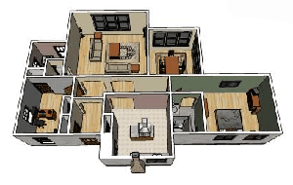 SOFTWARE

 Hardware
SOFTWARE - COMMUNICATING WITH USER
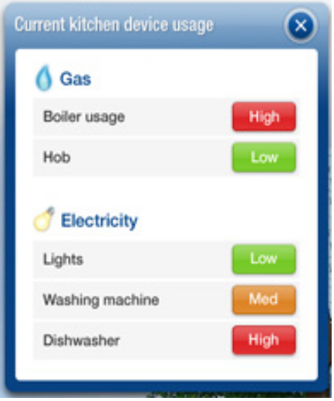

Spendings:

No. | Product Code | Product Name |  |  | Qty | Internet Price (USD) | Retail Price (USD) |  | Amount (USD)
1 | SK40C | Enhanced 40 pins PIC Start-Up Kit |  |  | 1 | 12.87 | 14.52 |  | 12.87
2 | DS-LCD-162A | LCD (16x2) |  |  | 1 | 6.77 | 8.06 |  | 6.77
3 | BD-BB-0508 | Breadboard (Small) |  |  | 1 | 2.74 | 3.00 |  | 2.74
4 | UIC00B | USB ICSP PIC Programmer V2010 |  |  | 2 | 16.42 | 18.71 |  | 32.84
5 | IC-PIC-18F4550 | IC PIC18F4550 |  |  | 1 | 8.06 | 9.68 |  | 8.06
6 | AD-TMC-500PM | Adapter Teletron TMC-500PM |  |  | 1 | 5.81 | 6.45 |  | 5.81
7 | WR-JW-MM65 | Male to Male Jumper Wire |  |  | 1 | 5.81 | 6.45 |  | 5.81
8 | SKXBEE-PRO | XBEE PRO STARTER KIT |  |  | 2 | 85.48 | 94.19 |  | 170.97
Total Amount : |  |  |  |  |  |  |  |  | 245.87
You save this with internet payment : |  |  |  |  |  |  |  |  | 28.10
Payable Amount : |  |  |  |  |  |  |  |  | 245.87
 |  |  |  |  |  |  |  |  | - 0.00
Shipping Fees : |  |  |  |  |  |  |  |  | 30.16
Grand Total : |  |  |  |  |  |  |  |  | 276.03
Item to Purchase |  |  | Qty. | Price after Options |  |  |  | Ext. Price |  | Remove
XBee Smart Plug  Item#: XR-Z14-CW2P6 |  |  |  | $84.00 |  |  |  | $168.00
Subtotal: |  |  |  |  |  |  |  | $444.03

Software Specifications: & Detailed Tasks:
C programming

Concept description and knowledge presentation:
Hardware solution
Software solution
Discussion
Conclusions
References
Language, English

